PHASE 3 – PROJECT DESIGN
Introduction:
- The Project Design phase defines the structure of the automated workflow for processing Standard Laptop requests.
- Based on the requirements identified in the previous phase, the project is designed using ServiceNow Flow Designer. The workflow is designed to create a Catalog Task after the Service Catalog request receives the required approval and assign the task to the Hardware group.
The project design consists of three main parts:
1. Flow Design
2. Flow Assignment to Standard Laptop Service Catalog
3. Standard Laptop Request and Approval Process
Flow Design:
The first part of the project design is to create a Flow in ServiceNow Flow Designer.
The Flow is designed with the following properties:
- Flow Name: Standard laptop task
- Application: Global
- Run User: System user
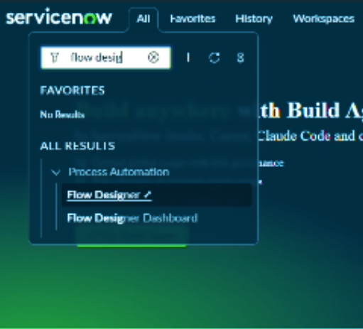
The Flow will use a Service Catalog trigger.

Flow Trigger Design:
- The trigger is designed to work with the Service Catalog.
- In Flow Designer, the Add a Trigger option is selected and the trigger Service Catalog is chosen.
- The Service Catalog trigger allows the workflow to respond to the relevant catalog request.
The trigger design is:
- Service Catalog Request → Flow Trigger
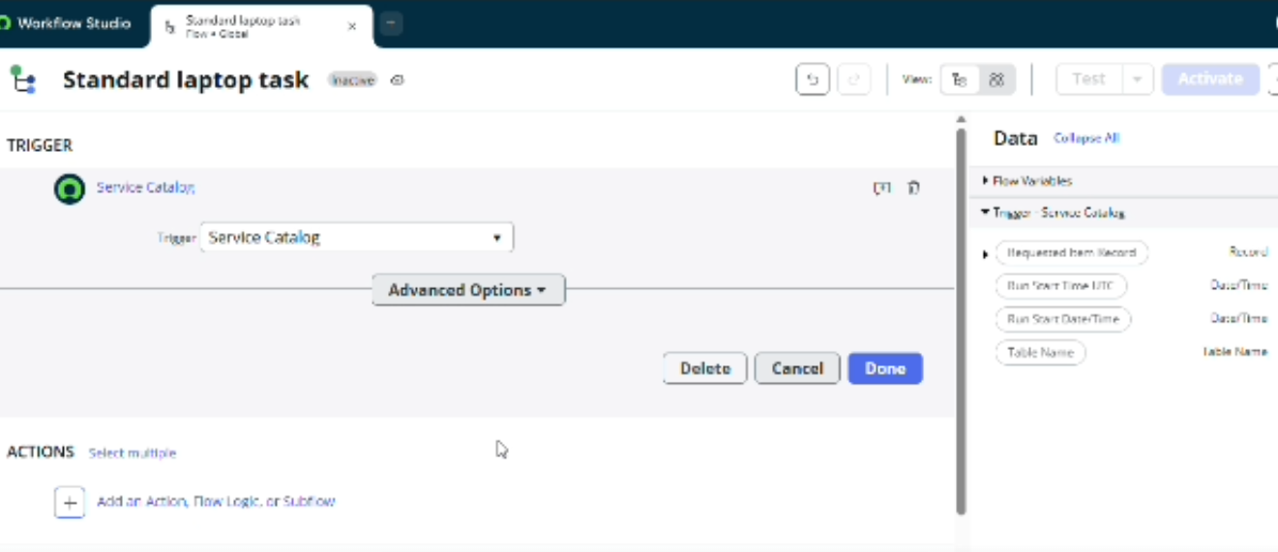

Create Catalog Task Action:
- After configuring the trigger, an action is added to the Flow.
The action selected is:
  - Create Catalog Task
  - The Requested Item Record is used as the Request item. The Table is automatically populated as Catalog Task.
The action is designed to create the required task for the laptop configuration process. 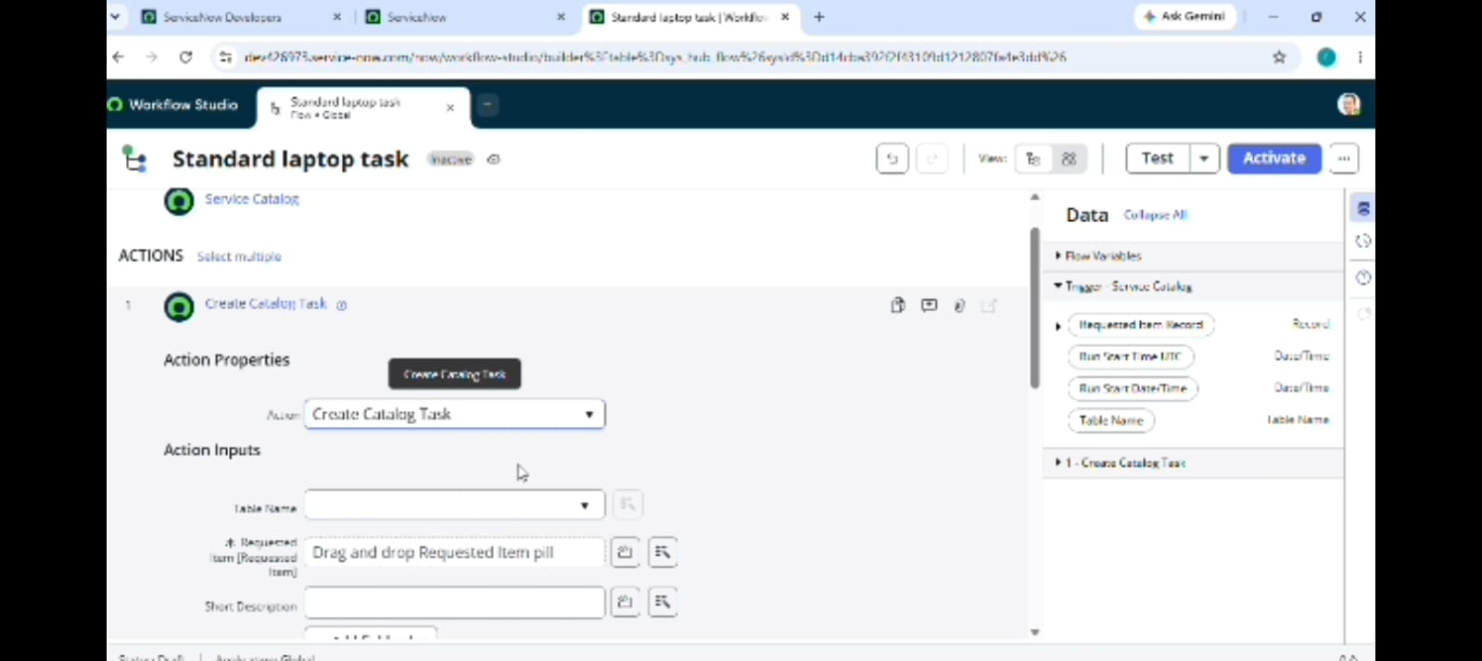
The Catalog Task is designed with the required information.
The following values are configured:
    - Action: Create Catalog Task
    - Request item: Requested Item Record
    - Table: Catalog Task
    - Short Description: Laptop need to Configured
    - Description: Laptop need to Configured
    - Assignment Group: Hardware
    - Approval: Approved
The remaining fields are kept as default according to the project reference instructions.
This configuration ensures that the required task is generated and assigned to the appropriate Hardware team after approval. 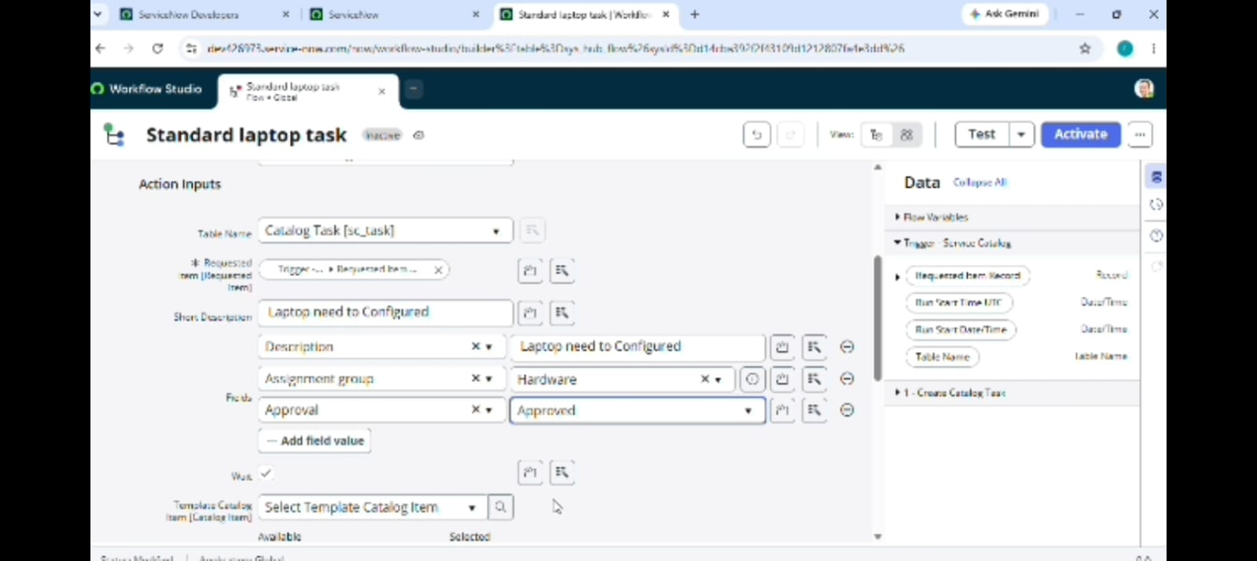
Flow Completion Design:
- After configuring the Create Catalog Task action, the action is completed by selecting Done.
- The Flow is then saved and activated.
The design sequence is:
- Create Flow → Add Trigger → Service Catalog → Add Action →
Create Catalog Task → Configure Fields → Done → Save → Act

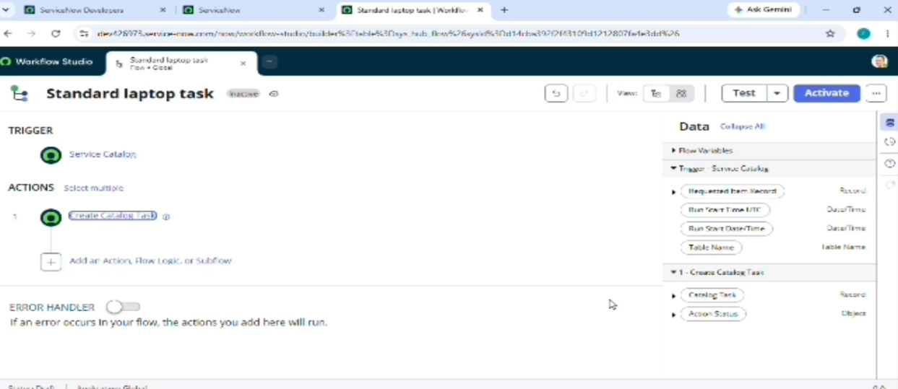

Flow Assignment Design:
- The second part of the project design is assigning the created Flow to the Standard Laptop Service Catalog item.
- The ServiceNow Maintain Items module is used to open the Standard Laptop record.
- Under the Standard Laptop record, the Process Engine section is selected.
- The remaining automations are removed and the created Flow named:
- Standard Laptop Task
- is added to the Standard Laptop Service Catalog item.
- The record is then saved. 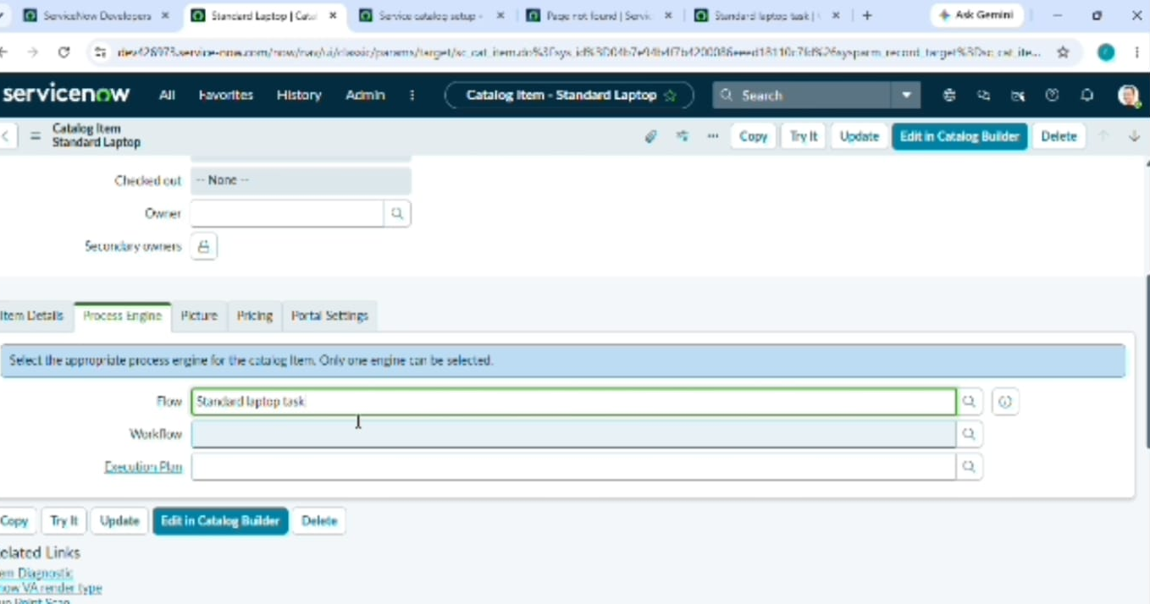
Service Catalog Design:
- The third part of the project design is the Service Catalog request process.
- The user accesses:
- All → Service Catalog → Hardware → Standard Laptop
- The user then selects Order Now to place the Standard Laptop request.
- The request status can then be viewed through the Order Status section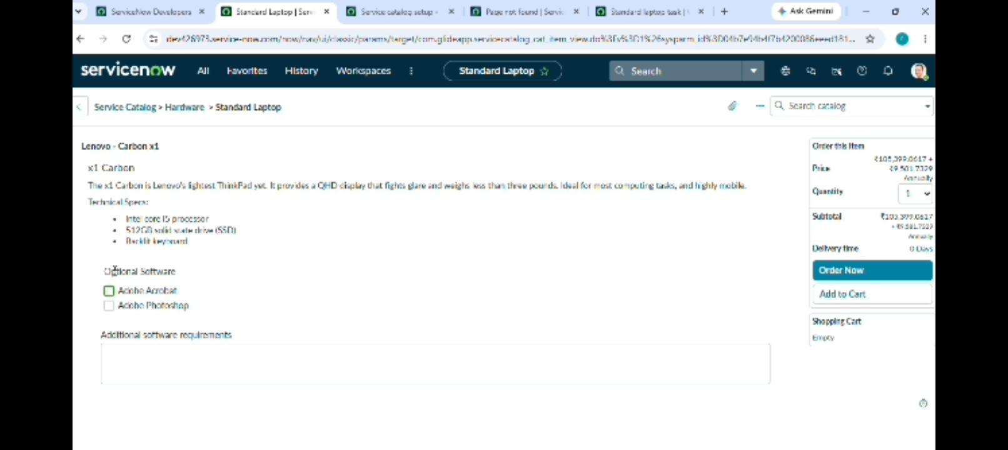
Approval Design:
- After placing the Standard Laptop request, the request number is opened to view the requested record.
- The Approvers section is then accessed.
- The appropriate request record is approved.
The approval is an important part of the workflow because the designed process creates the Catalog Task after the required approval.
The approval flow can be represented as:
- Standard Laptop Request → Request Number → Approvers → Approved
- 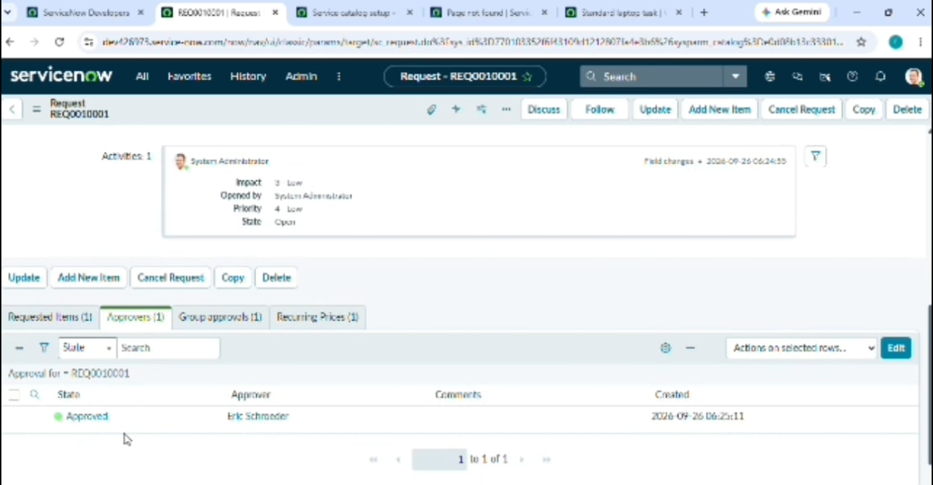

Catalog Task Output Design:
- After approval, the Requested Item section is opened.
- The Catalog Tasks section is then viewed.
The generated Catalog Task contains the configured information, including:
  - Updated status
  - Short Description
  - Assigned Group
The task should show the short description:
- Laptop need to Configured
- and the assigned group
- Hardware
This Confirms the intended output of the designed workflow.
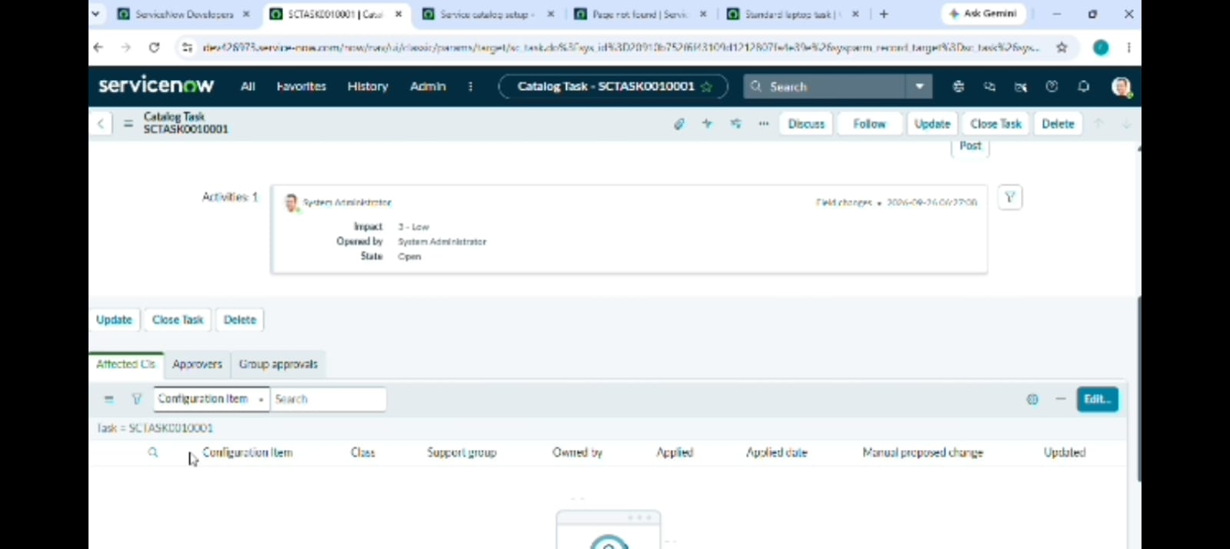

Catalog Task Output Design:
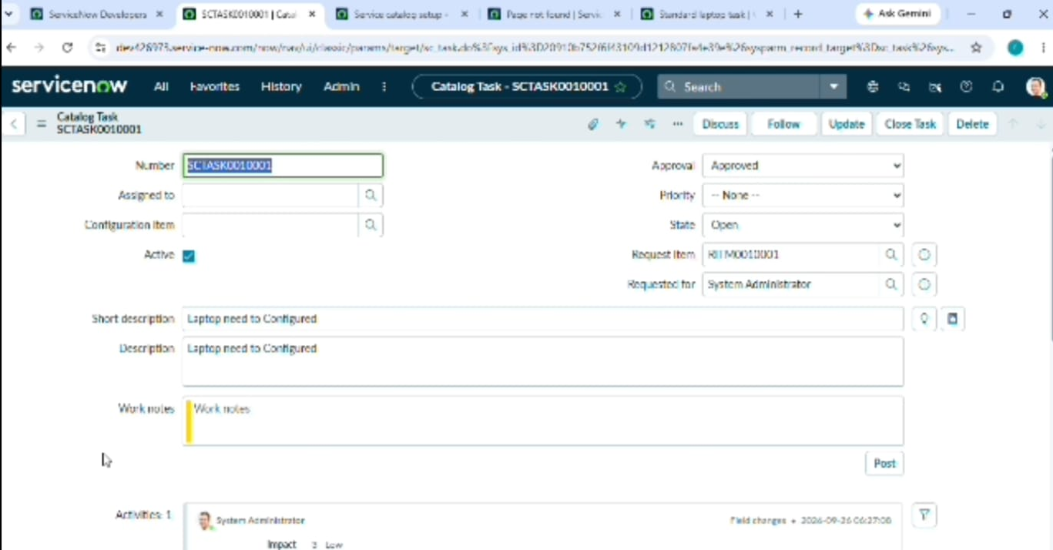
Overall Project Design:
The complete project design can be represented as follows:
Standard Laptop Service Catalog
↓
Place Order
↓
Request Approval
↓
Service Catalog Trigger
↓
Create Catalog Task
↓
Short Description – Laptop need to Configured
↓
Assignment Group – Hardware
↓
Hardware Team Configuration
This design connects the Service Catalog request, approval process, Flow Designer automation, and Hardware task assignment into one workflow.
Design Components:
The main components used in the project design are:
1. ServiceNow Flow Designer
2. Service Catalog
3. Standard Laptop Catalog Item
4. Service Catalog Trigger
5. Create Catalog Task Action
6. Requested Item Record
7. Catalog Task
8. Hardware Assignment Group
9. Approval Process
These components work together to implement the automated Standard Laptop procurement process

Design Summary:
- The Project Design phase defines how the Standard Laptop procurement automation will work in ServiceNow.
- The design starts with a Standard Laptop Service Catalog request. The request goes through the required approval process. After approval, the Service Catalog trigger starts the Flow, which creates a Catalog Task with the required description and assigns it to the Hardware group.
- The Flow is also assigned to the Standard Laptop Service Catalog item through the Process Engine configuration.
- This design provides the structure required for implementing the project in the development phase.

